**How to Create a Customer Message Using Pendo**

Steps:

1. Go to [https://www.pendo.io](https://www.pendo.io/) using your favorite web browser.
   1. 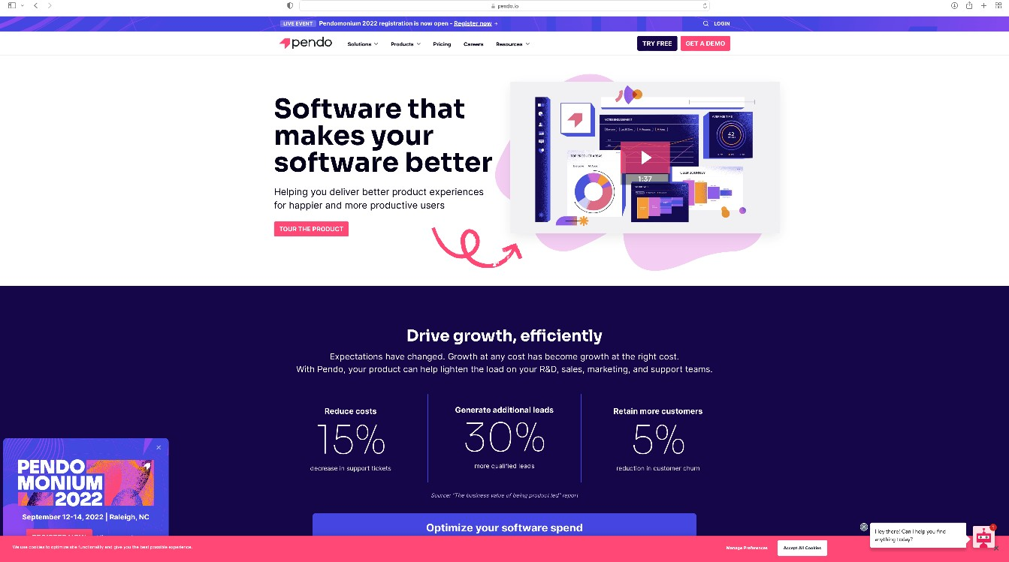Note: For the best results, you should use Google Chrome.

*Figure 1: Pendo Welcome Page*

1. Click the login button on the toolbar.

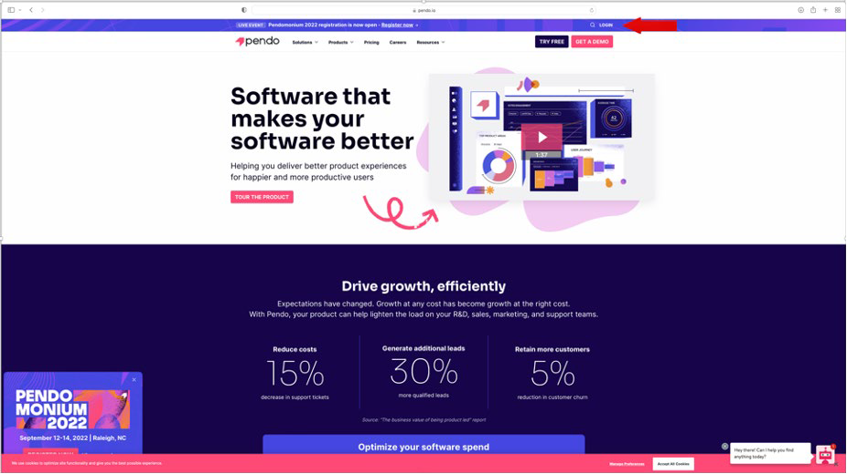

*Figure 2: Pendo Login*

1. Enter the email address associated with the account and click **Sign In**. The password page displays.

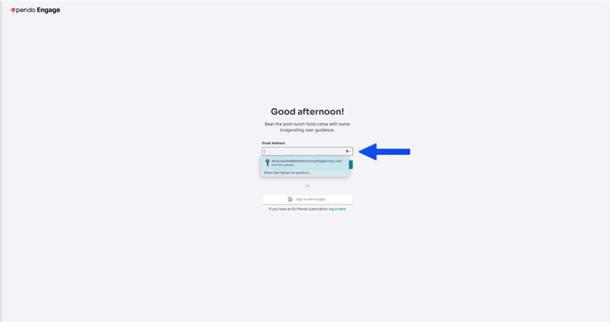

*Figure 3: Enter Email Address*

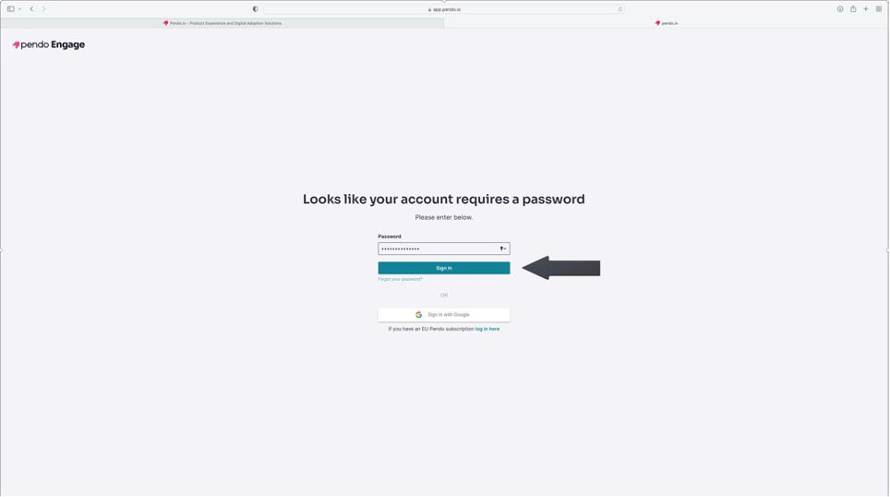

*Figure 4: Click Sign In*

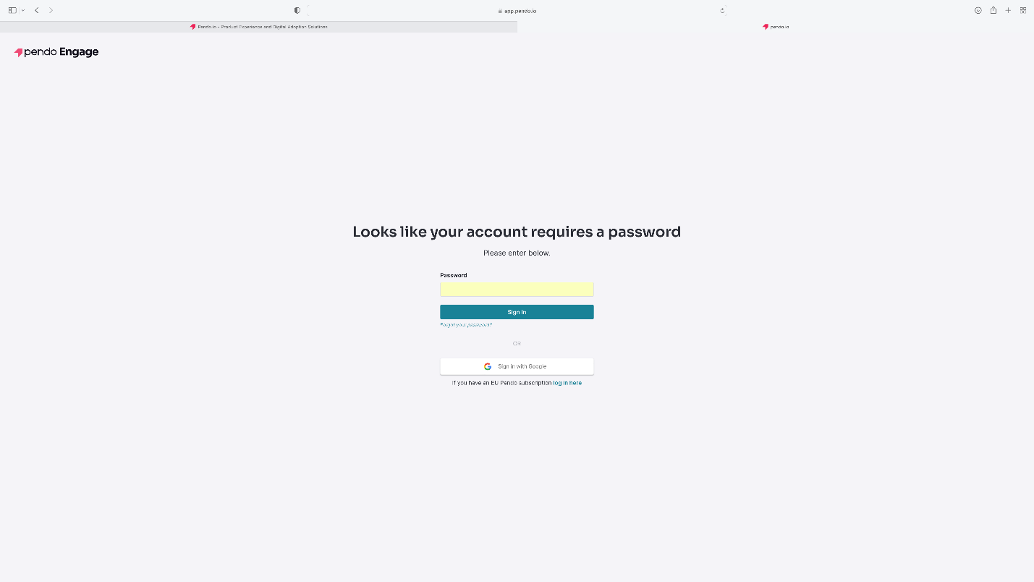

*Figure 5: Password Page*

1. Enter the password associated with the account and click **Sign In**.

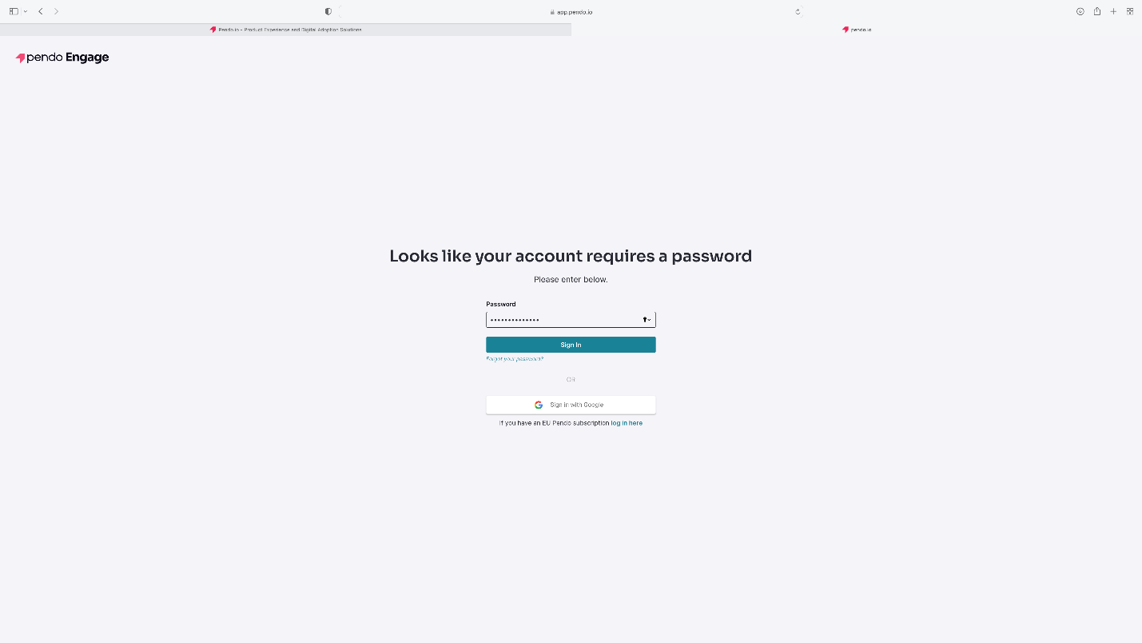

*Figure 6: Enter Password and Click Sign In*

1. The Pendo Dashboard displays.

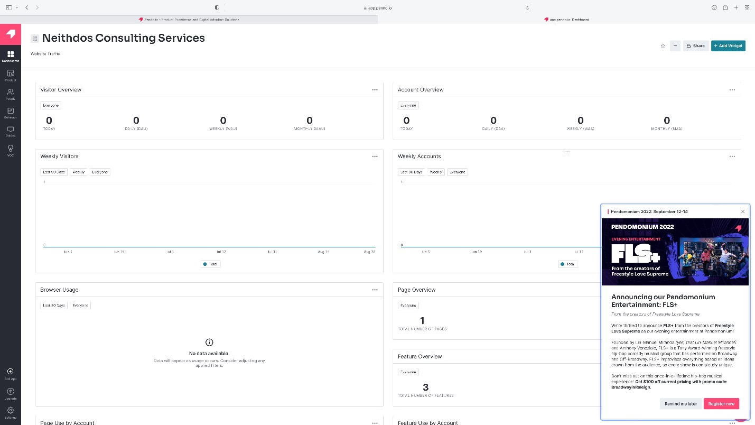

*Figure 7: Pendo Dashboard*

1. To view announcements from Pendo, click on the Pendo logo on the lower right-hand corner of the dashboard. The Resource Center will open and display the announcements. To exit the Resource Center, click “X” in the upper right-hand corner.

*Figure 8: Resource Center*

1. Click **Guides** in the toolbar on the left-hand side of the dashboard.

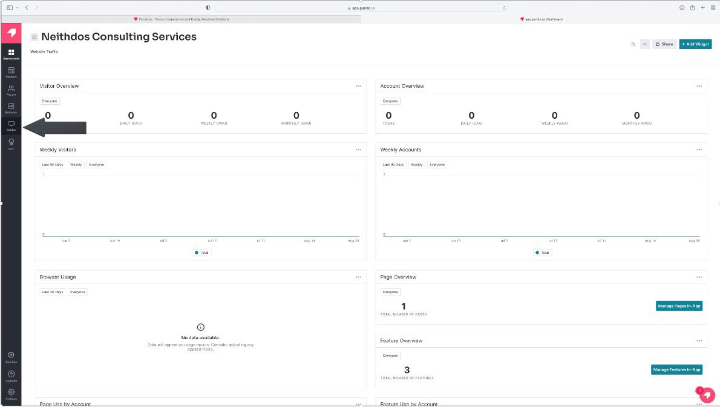

*Figure 9: Click Guides*

1. Click **Guides** from the Guides menu. The Guide dashboard displays.

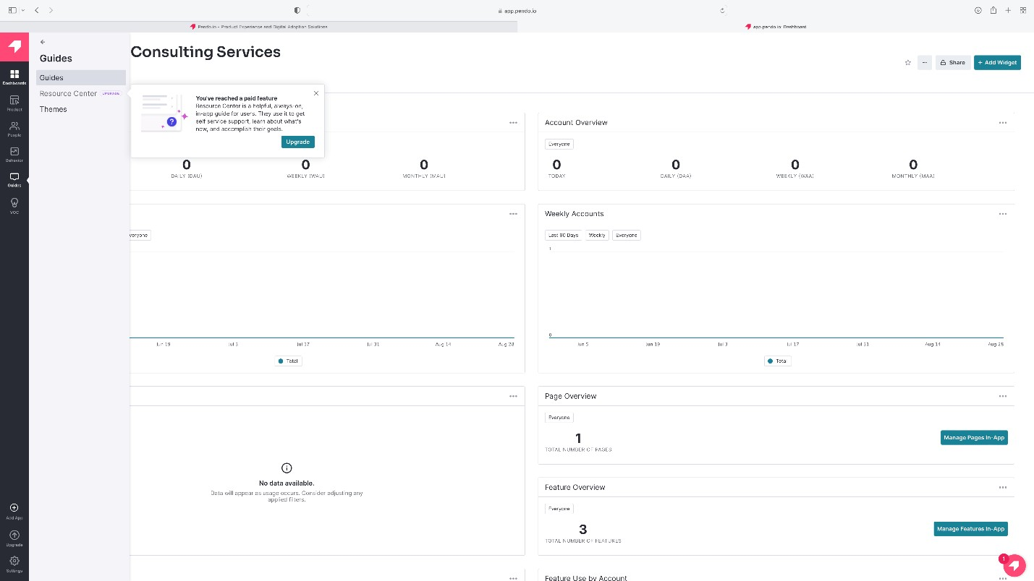

*Figure 10: Click Guides from the Guide Menu*

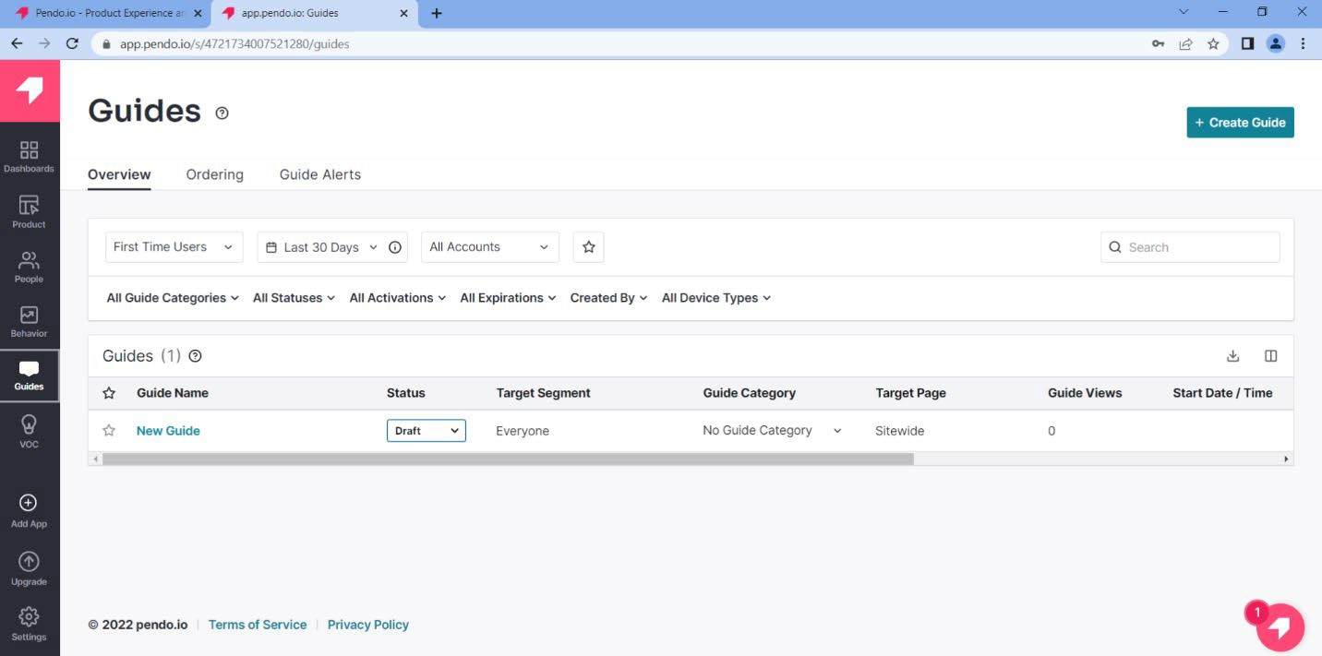

*Figure 11: Guides Dashboard*

1. Click the **“+ Create Guide”** button.
2. From the Create Guide dashboard, select *Default* from the Theme pull-down menu. Then, select the guide's theme. For this guide, we will choose “Lightbox: Start from Scratch.”

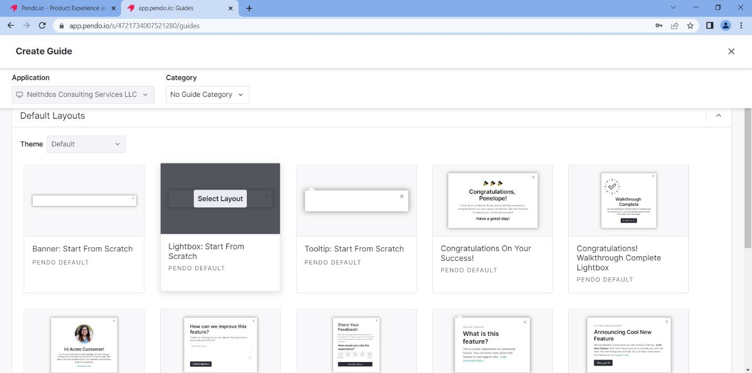

*Figure 12: Default Layout: Lightbox Start from Scratch*

1. Click the **Select Layout** button.
2. Create a name for the Guide in the Blue Highlighted area.

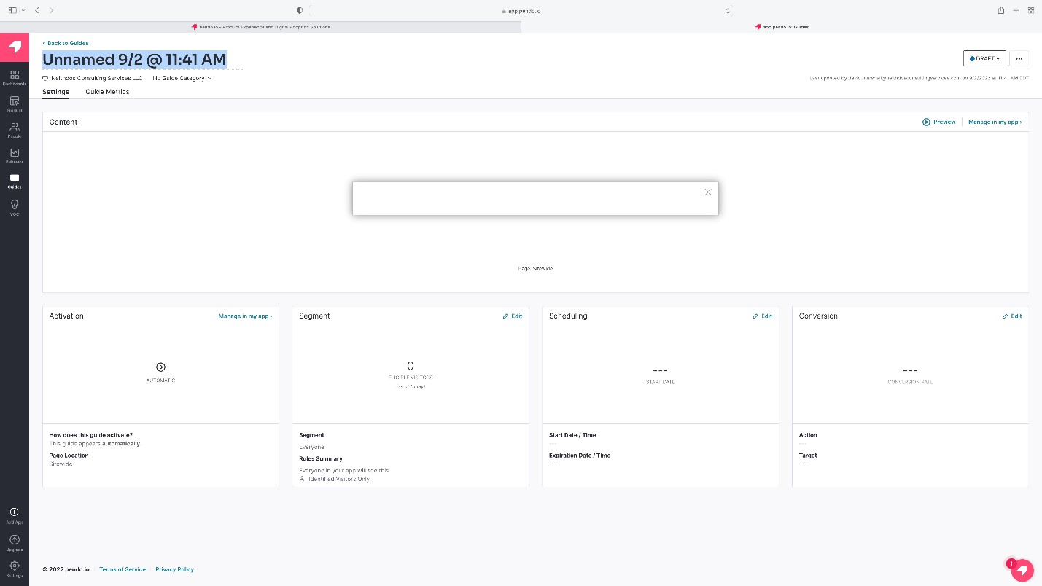

*Figure 13: Name the Guide*

1. In the Content area, enter the website’s URL, where the customer’s message will be displayed. For this example, we will use [https://www.neithdosconsultingservices.com](https://www.neithdosconsultingservices.com/).

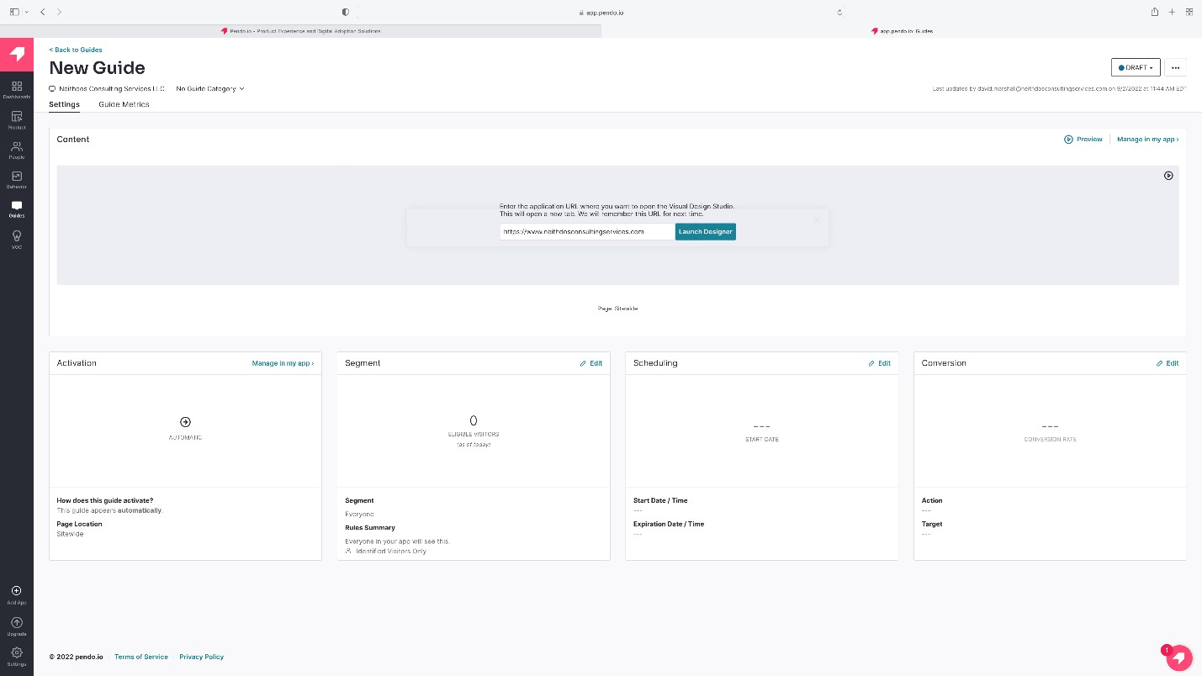

*Figure 14: URL of the Website*

1. Click “**Launch Designer**”

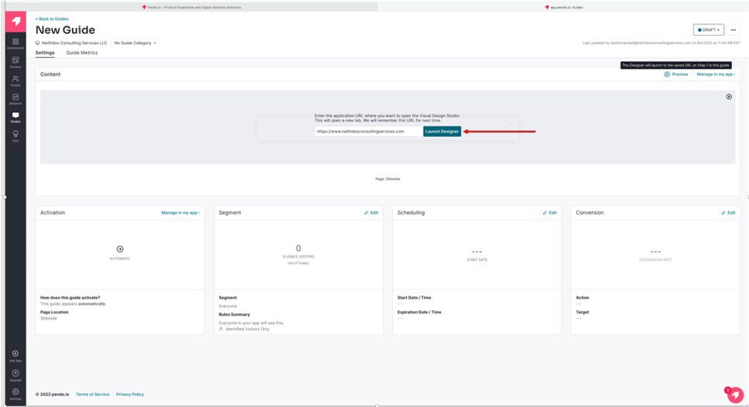

*Figure 15: Launch Designer*

1. The website with the Edit Container menu displays.

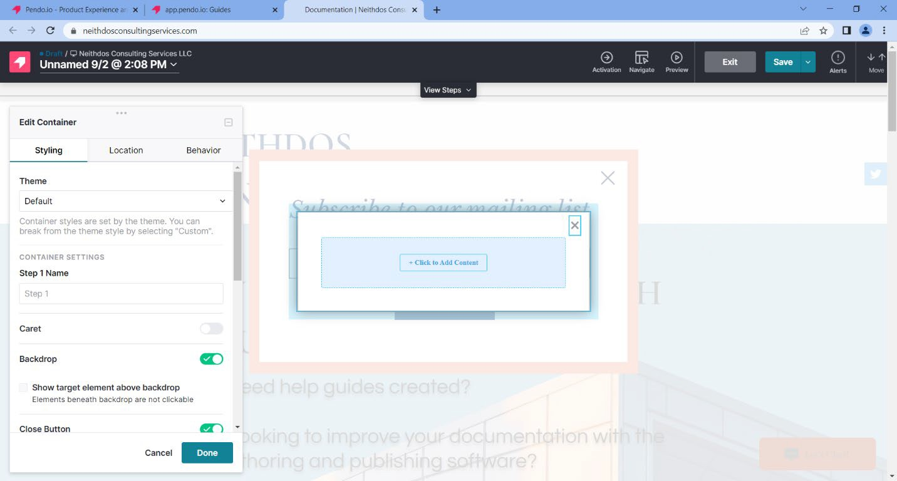

*Figure 16: Website with the Edit Container*

1. Click **“+ Click to Add Content**.”

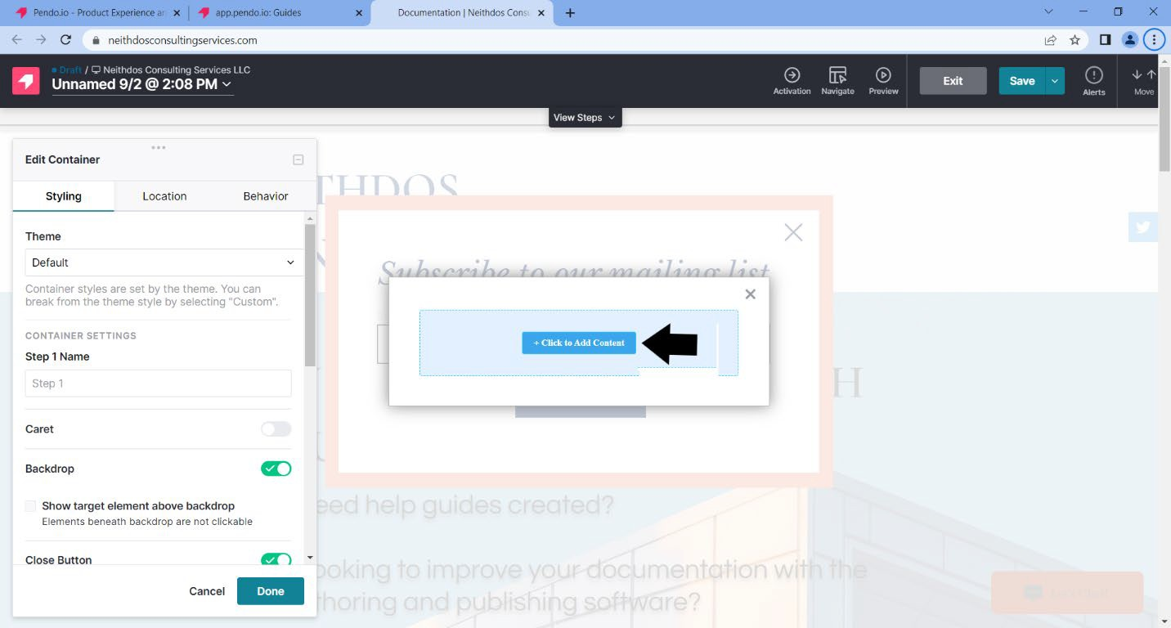

*Figure 17: Add Content*

1. On the left-hand side, under Building Blocks – General, select “**Text.**”

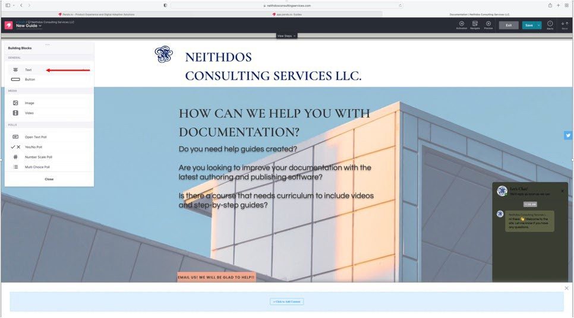

*Figure 18: Text Building Block*

1. Select “Custom” from the pull-down menu on the left-hand side under Theme Style.

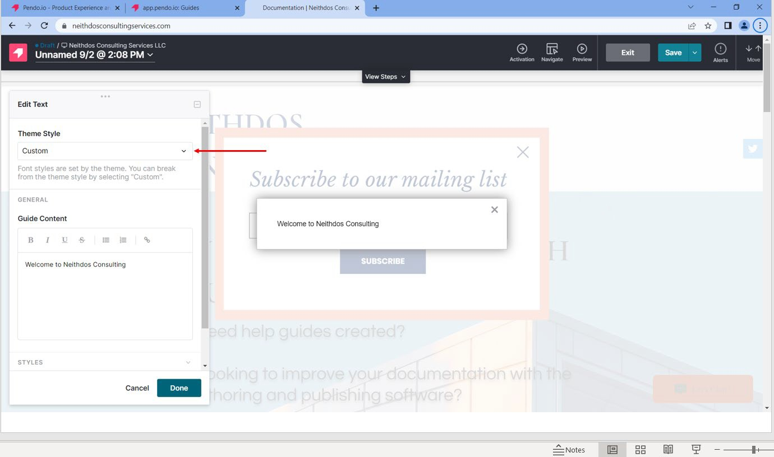

*Figure 19: Theme Style – Custom*

1. In the Guide Content area, type the message or information.

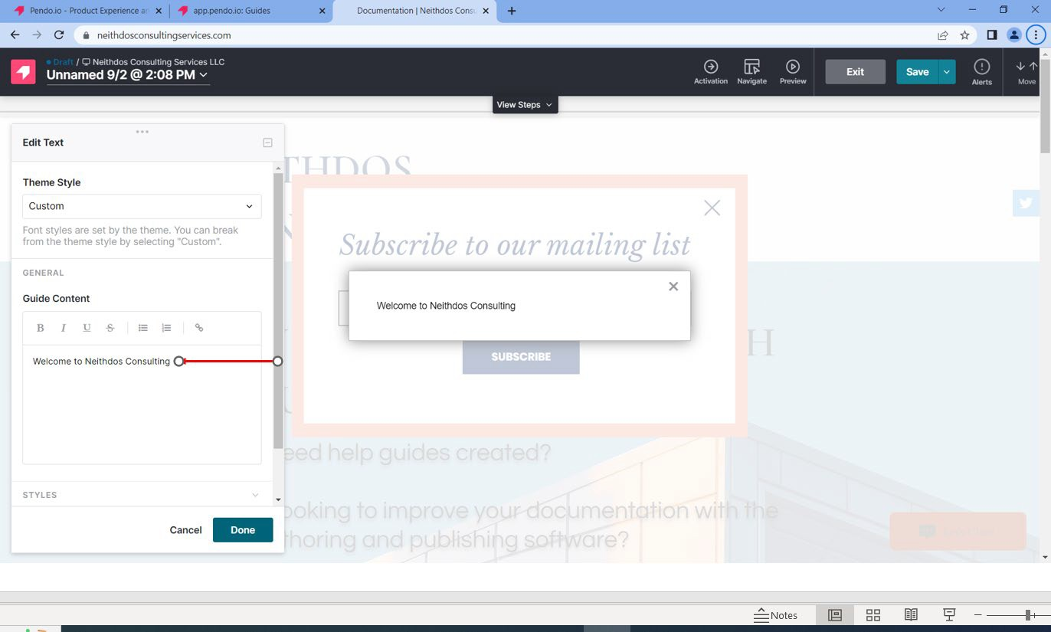

*Figure 20: Customer Message*

1. Click **Done.**

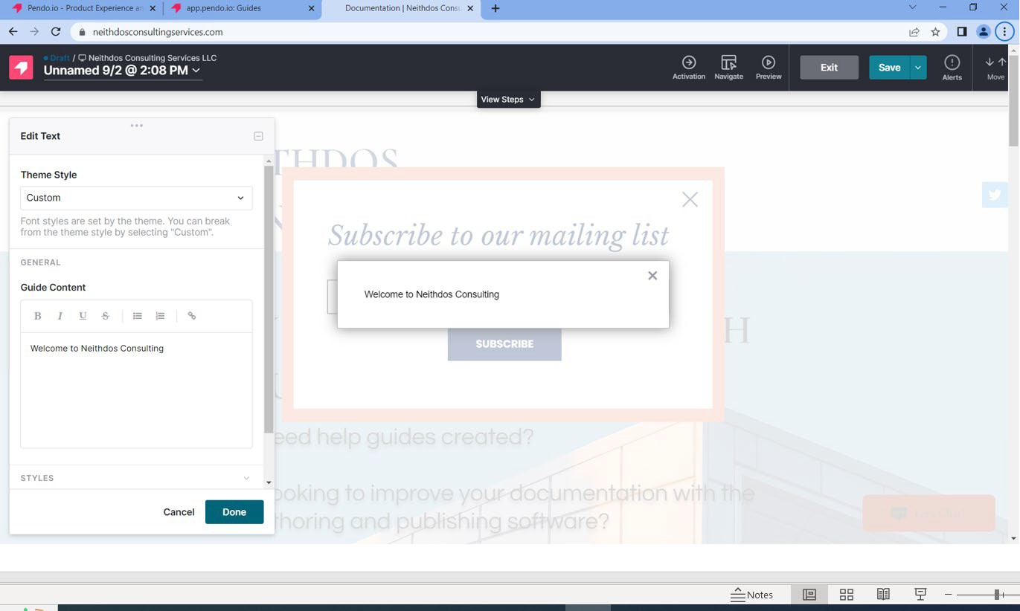

*Figure 21: Theme Style – Done*

1. Click the “Save” button located in the upper right-hand corner.

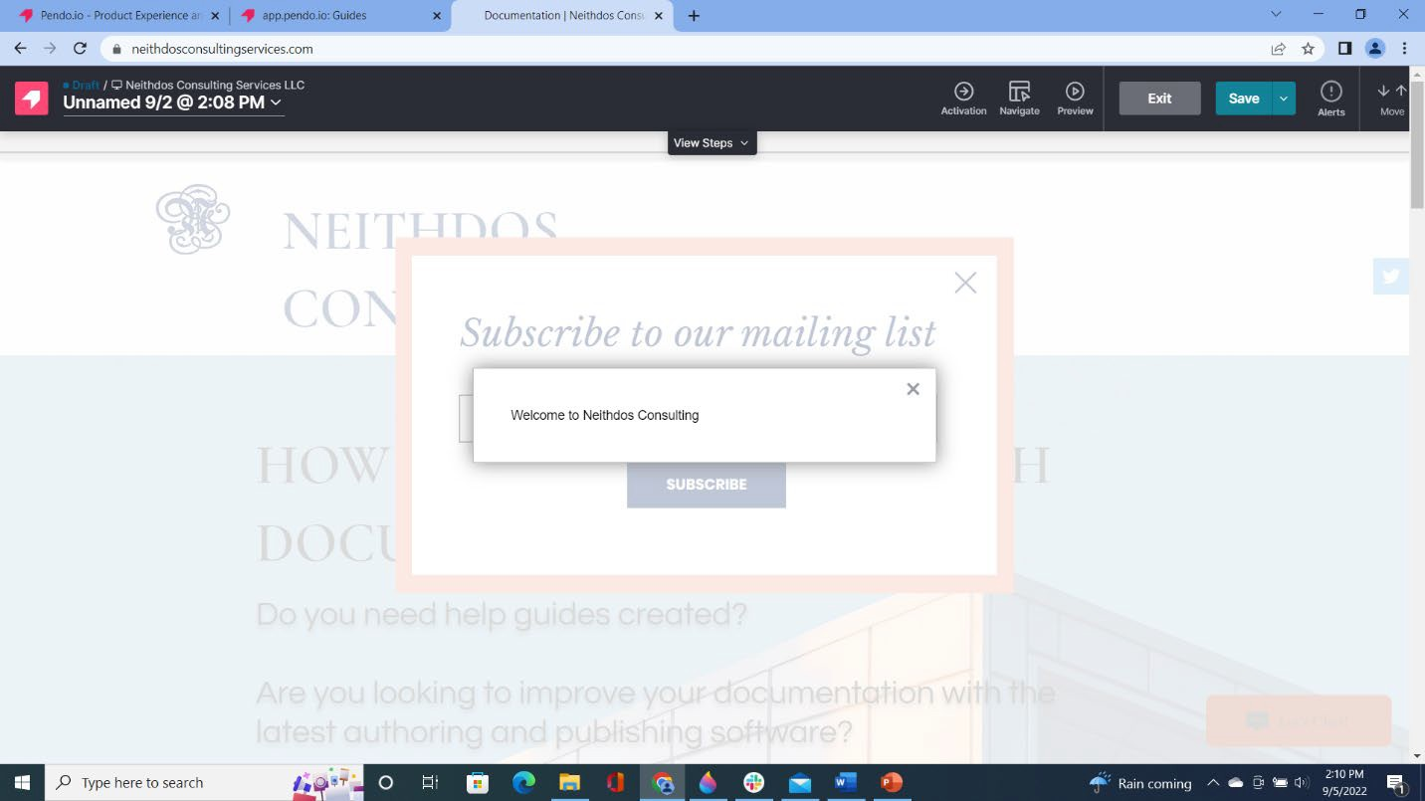

*Figure 22: Save - Upper Right-Hand Corner*

1. Click the “Exit” button located in the upper right-hand corner. The Guide dashboard displays.
2. Click “Preview” to test the newly created guide and the customer message.

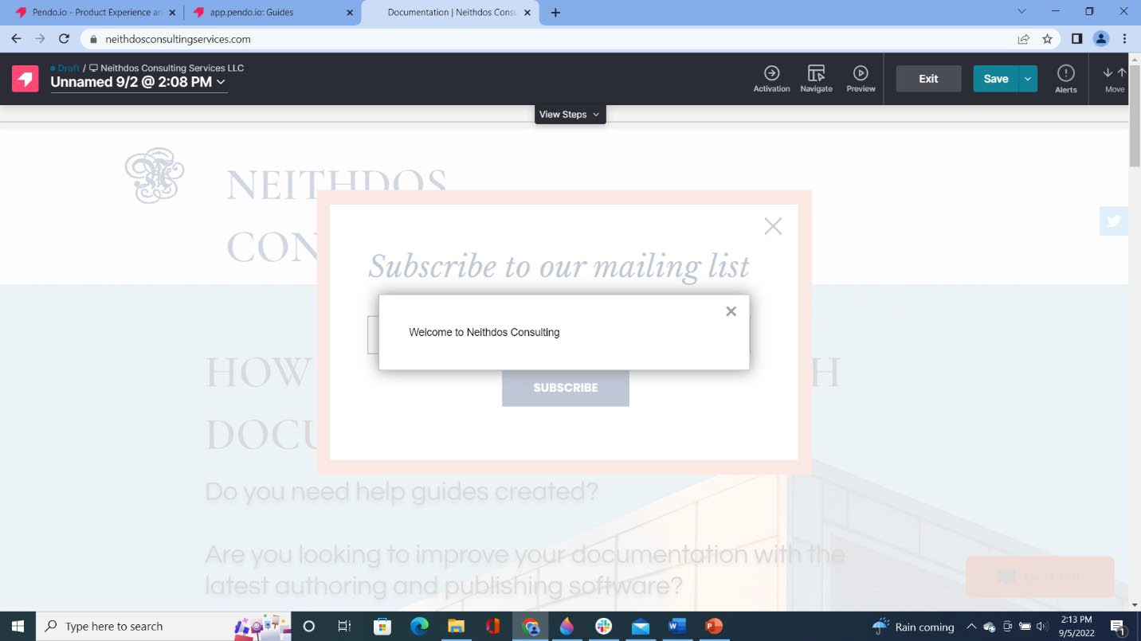

*Figure 23: Exit - Upper Right-Hand Corner*

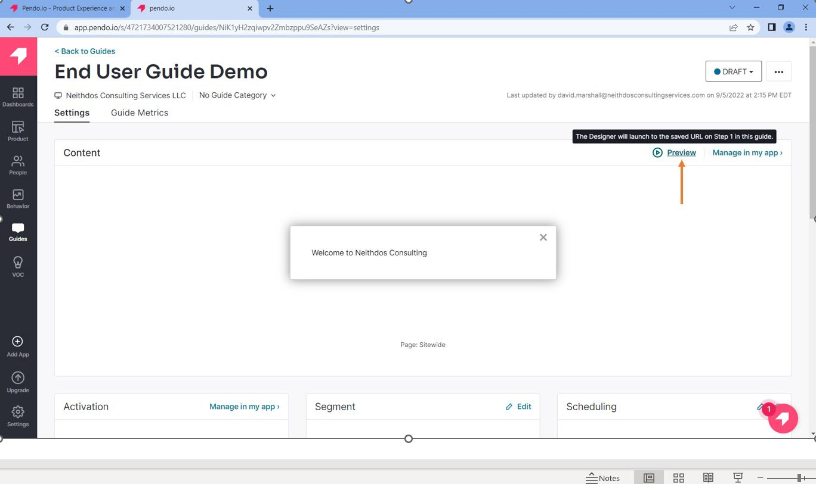

*Figure 24: Click Preview*

1. The customer message will appear on the website.

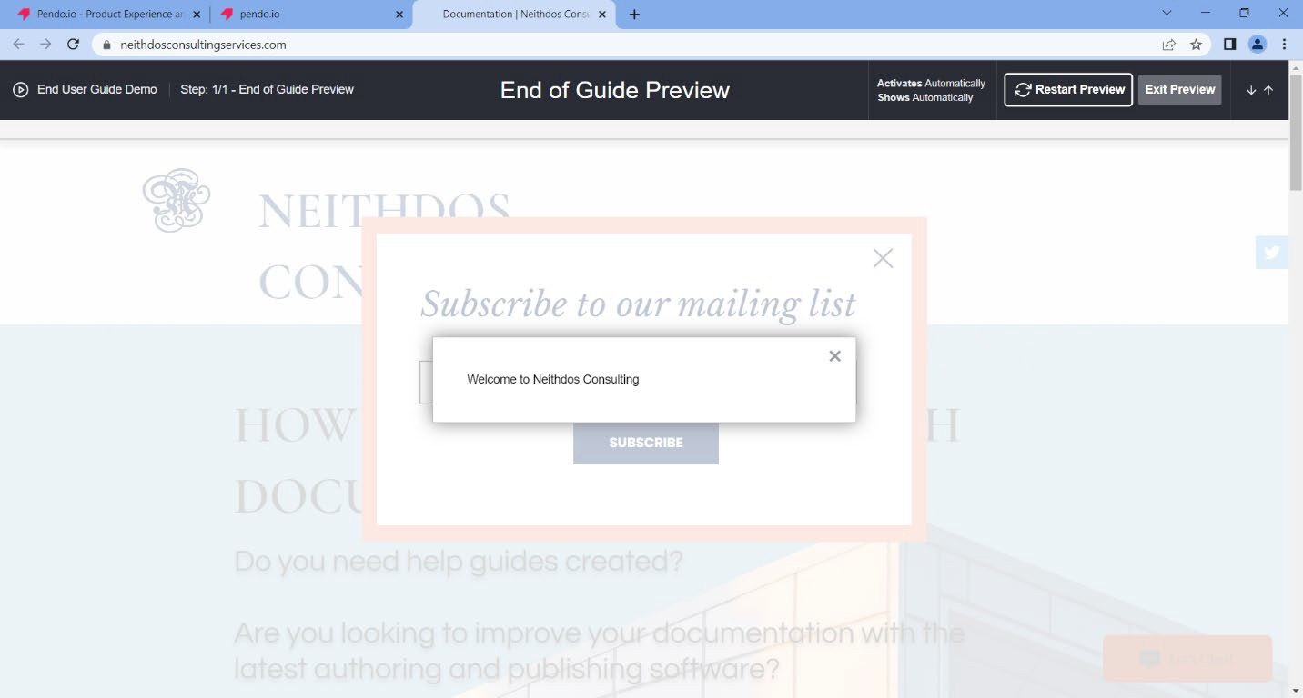

*Figure 25: Website Confirmation*

1. Click Exit Preview.

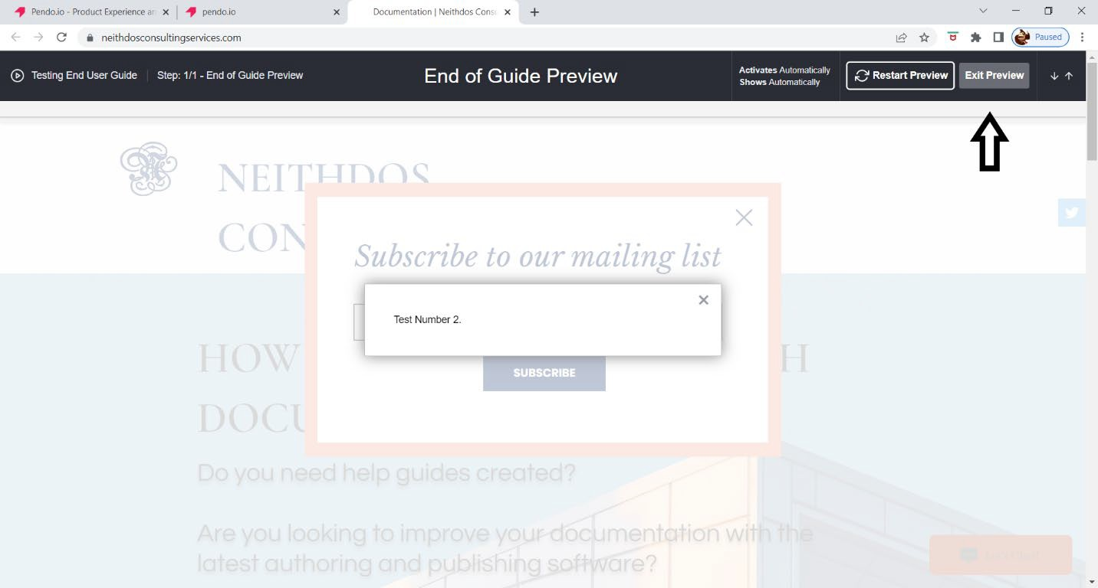

*Figure 26: Exit Preview*