**Pendo User Guide**

FOR

**Beginners**

Version 1.0

2024 August 22

**Revision History**

The table below identifies all changes that have been incorporated into this document.

| Version | Draft Date | Summary of Change | Point of Contact |
| --- | --- | --- | --- |
| 1.0 | 8/22/2024 | Initial | Neithdos |
|  |  |  |  |
|  |  |  |  |

**Table of Contents**

Introduction 1

Steps 1

**List of Figures**

Figure 1: Pendo Welcome Page 1

Figure 2: Pendo Log In button 1

Figure 3: Enter email address 2

Figure 4: Sign In button 2

Figure 5: Password page 3

Figure 6: Sign In button 3

Figure 7: Pendo dashboard 4

Figure 8: Pendo Resource Center 4

Figure 9: Guides option 5

Figure 10: Guides option from the Guide menu 6

Figure 11: Guides dashboard 6

Figure 12: +Create Guide button 7

Figure 13: Theme pull-down menu 7

Figure 14: Selecting Theme 8

Figure 15: Create a name for Guide 8

Figure 16: Enter URL 9

Figure 17: Launch Designer 9

Figure 18: +Click to Add Content 10

Figure 19: Text option 11

Figure 20: Custom option 11

Figure 21: Customer message 12

Figure 22: Save button 13

Figure 23: Exit button 14

Figure 24: Preview option 14

Figure 25: Website message 15

Figure 26: Exit Preview 15

Figure 27: Back to Guides 16

Figure 28: The newly created guide is listed 16

# Introduction

This user guide is for beginners using the Pendo product for the first time. In this guide, we will create a welcome message.

# Steps

1. Type <https://www.pendo.io> in the web address bar.
   1. Note: For the best results, you should use Google Chrome.

Figure 1: Pendo Welcome Page

1. Click **Log in** on the toolbar.

Figure 2: Pendo Log In button

1. Enter the email address associated with the account.

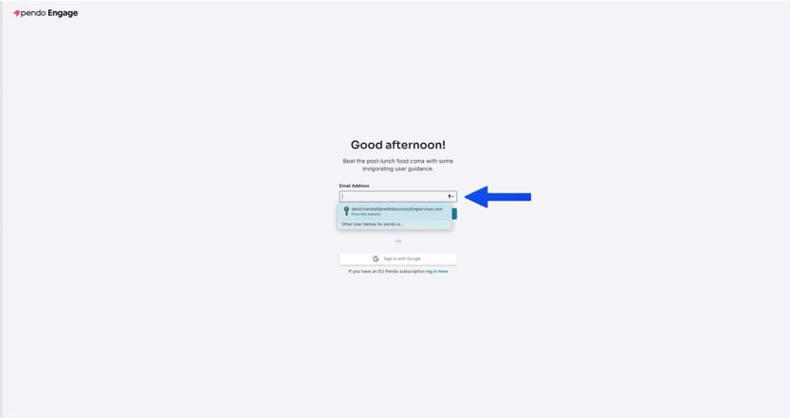

Figure 3: Enter email address

1. Click **Sign In**.

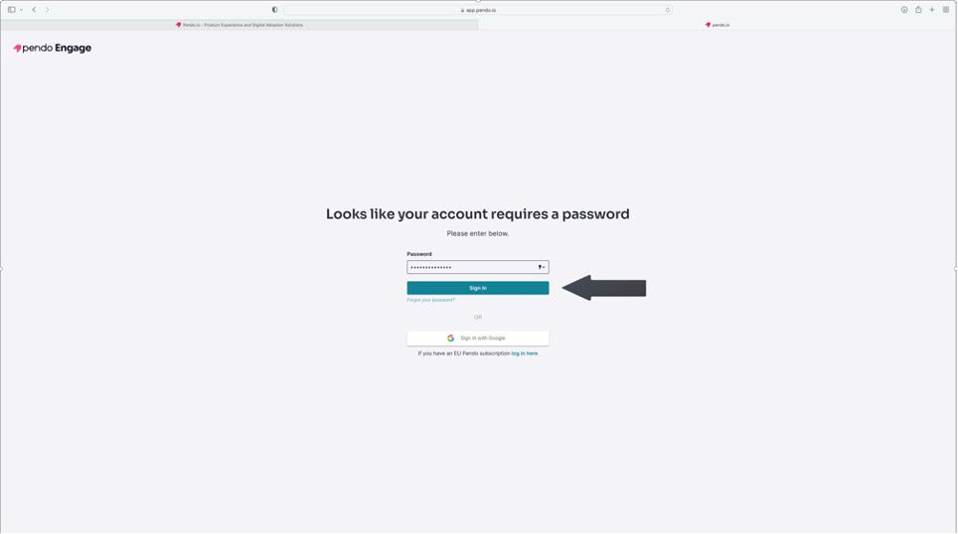

Figure 4: Sign In button

1. Enter the account password.

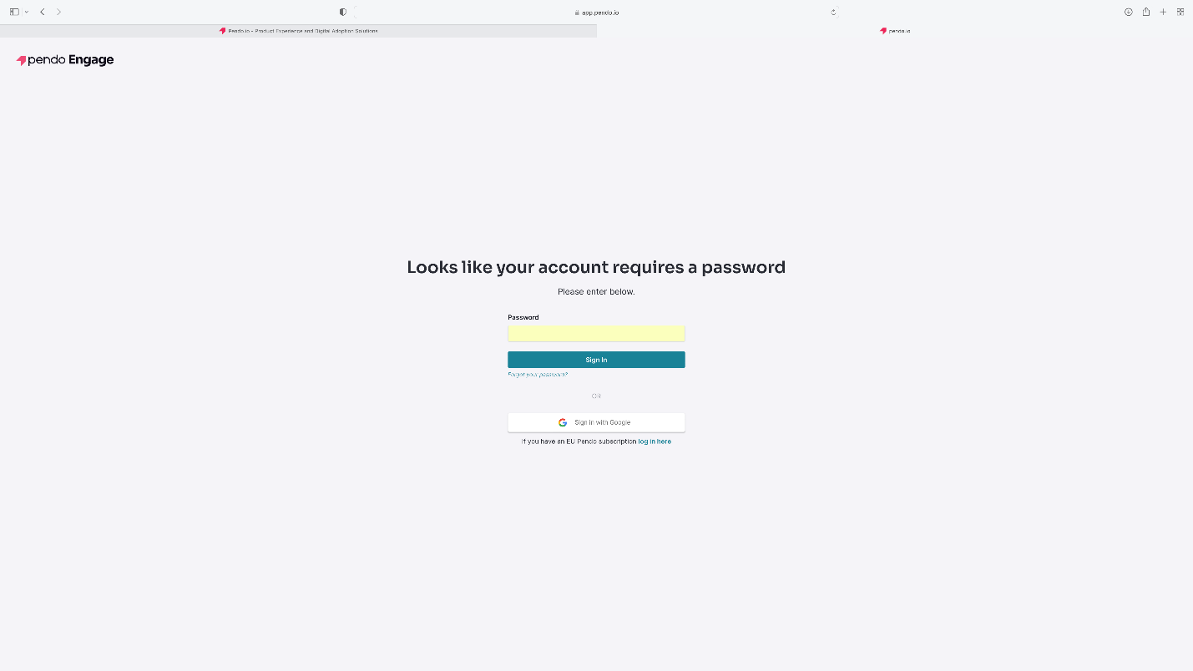

Figure 5: Password page

1. Click **Sign In**.

Figure 6: Sign In button

1. The Pendo Dashboard displays

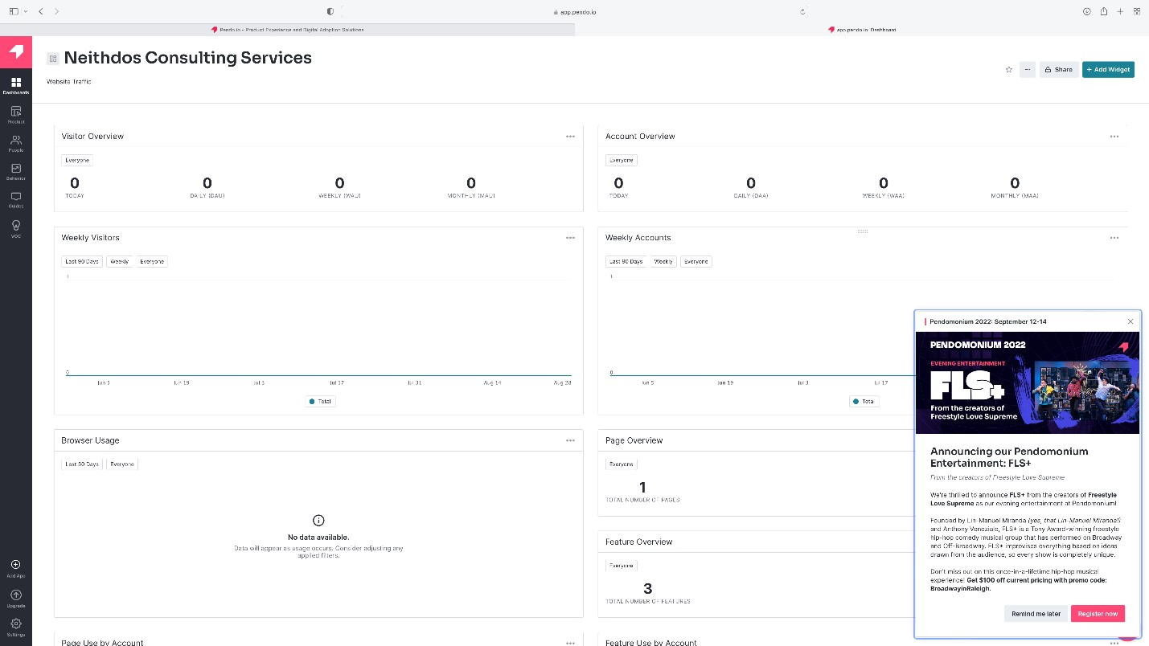

Figure 7: Pendo dashboard

1. To view the announcements, click on the Pendo logo on the lower right-hand corner of the dashboard. The Resource Center opens, displaying the notifications. To exit the Resource Center, click “X” in the upper right corner.

Figure 8: Pendo Resource Center

1. Click **Guides** in the toolbar on the left-hand side of the dashboard.

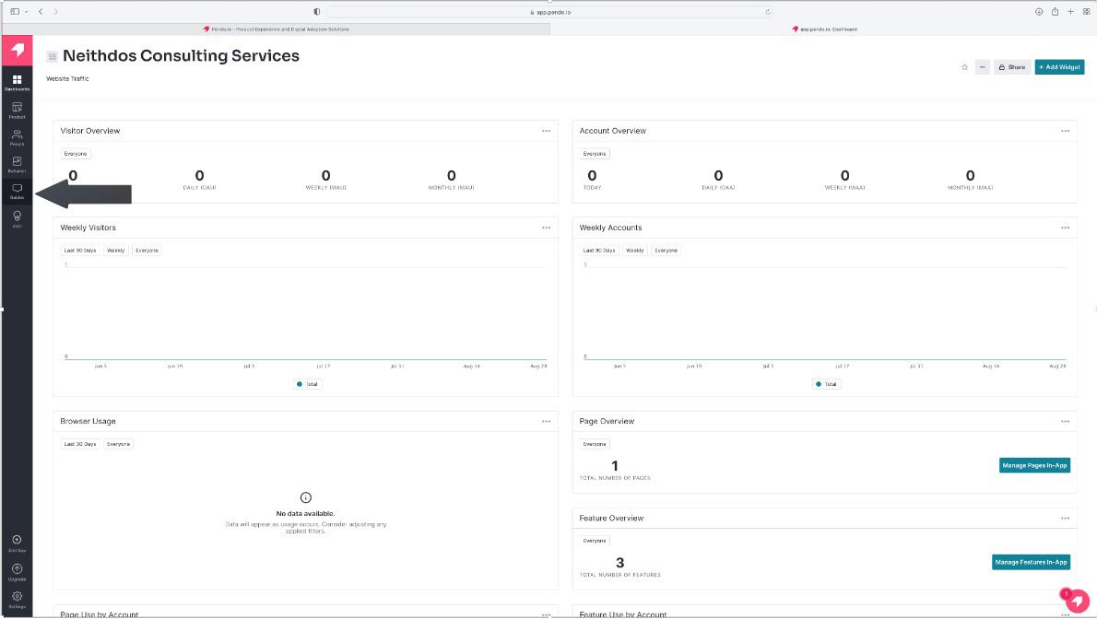

Figure 9: Guides option

1. Click Guides for the Guides menu—the Guide dashboard displays.

Figure 10: Guides option from the Guide menu

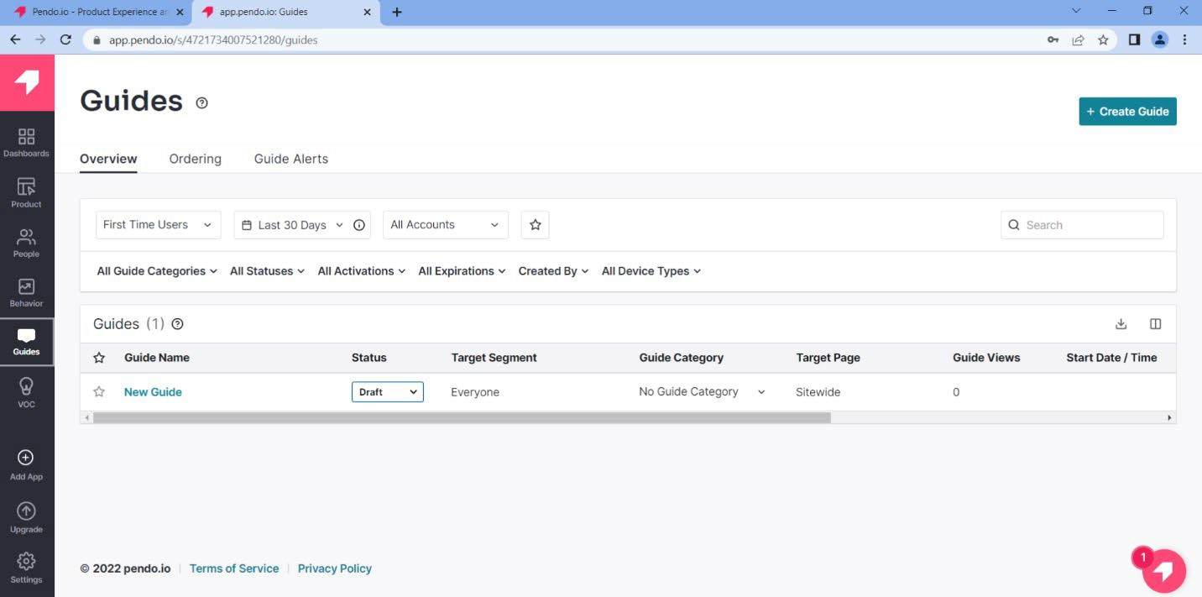

Figure 11: Guides dashboard

1. Click **+Create Guide**.

Figure 12: +Create Guide button

1. Select *Default* from the Theme pull-down menu.

Figure 13: Theme pull-down menu

1. Select the guide's theme. For this guide, we will select “Lightbox: Start from Scratch.”

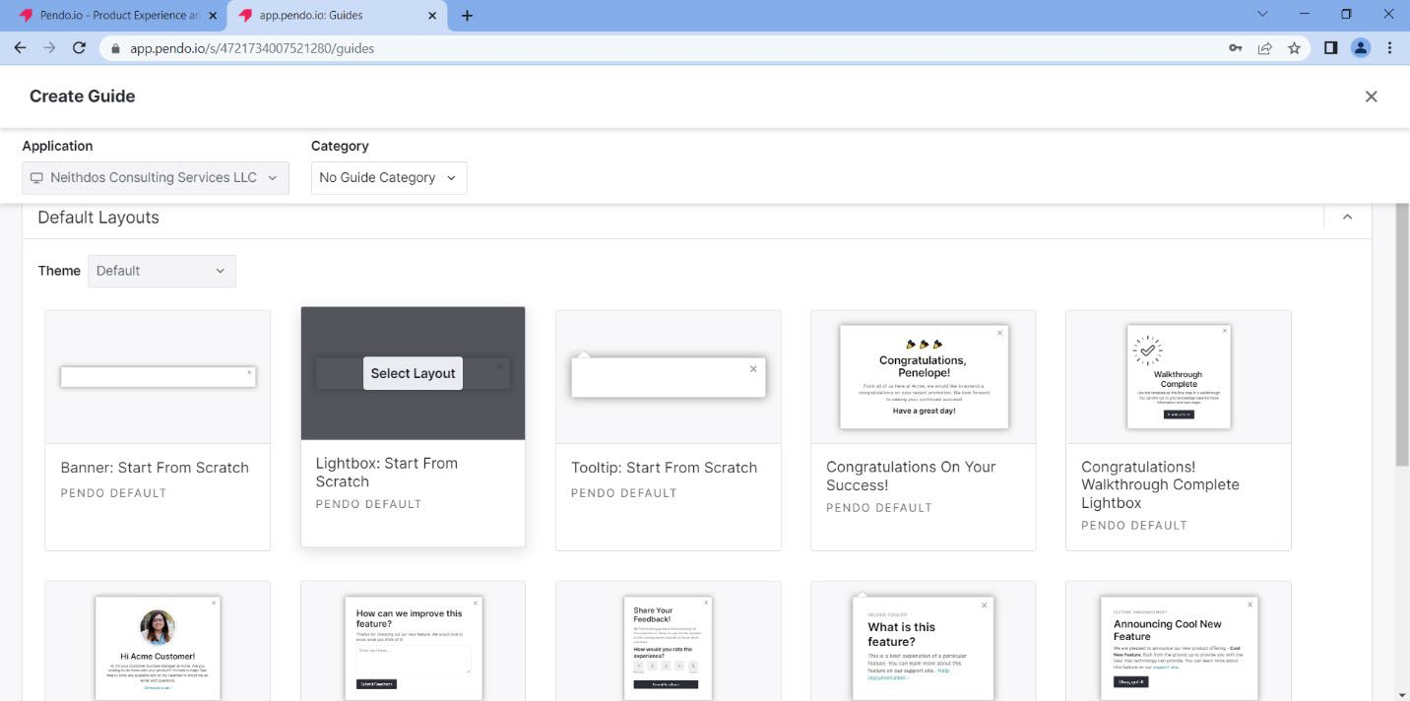

Figure 14: Selecting a theme

1. Click **Select Layout**.
2. Create a name for the guide in the blue highlighted area.

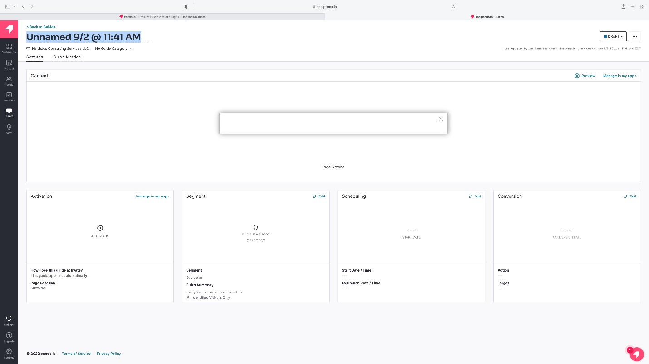

Figure 15: Create a name for the guide

1. In the Content area, type in the website URL where the customer’s name will be displayed. For this example, we will use <https://www.neithdosconsultingservices.com>

Figure 16: Enter URL

1. Click **Launch Designer**.

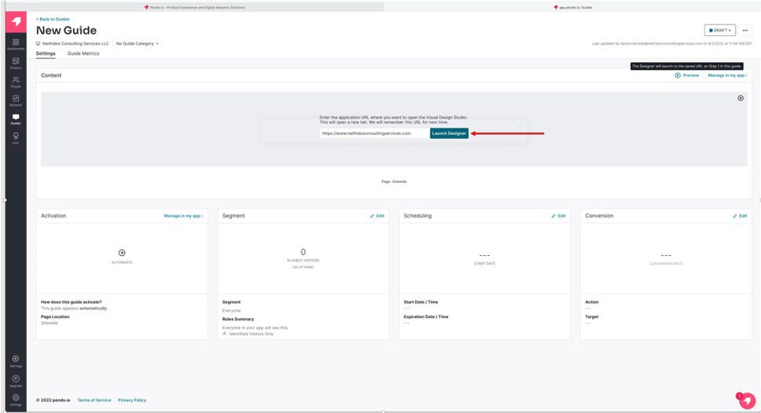

Figure 17: Launch Designer

1. Click **+Click to Add Content** on the Edit Container.

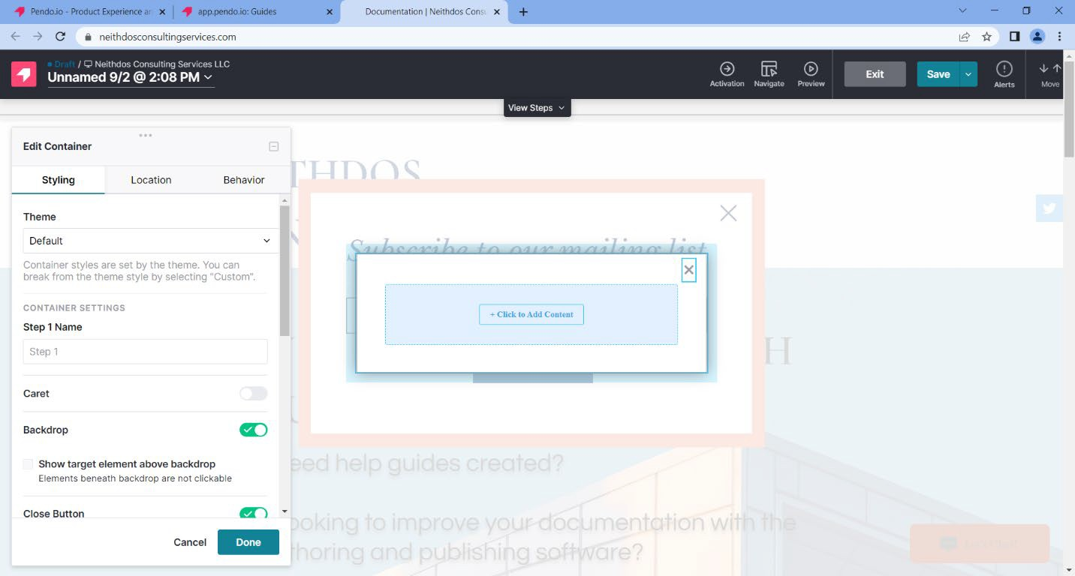

Figure 18: +Click to Add Content

1. Select Text under *Building Blocks*

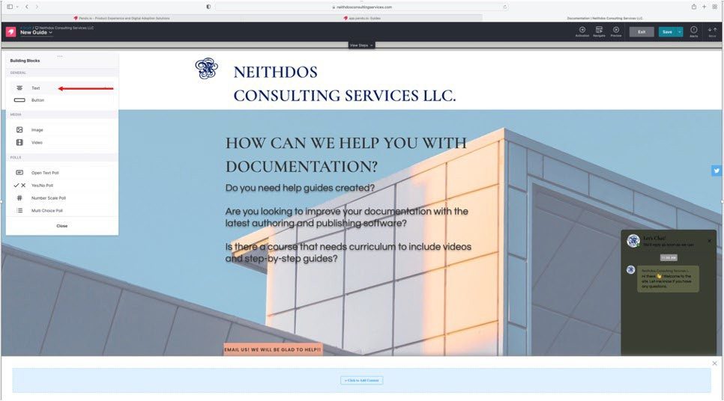

Figure 19: Text option

1. Select **Custom** under *Theme Style*.

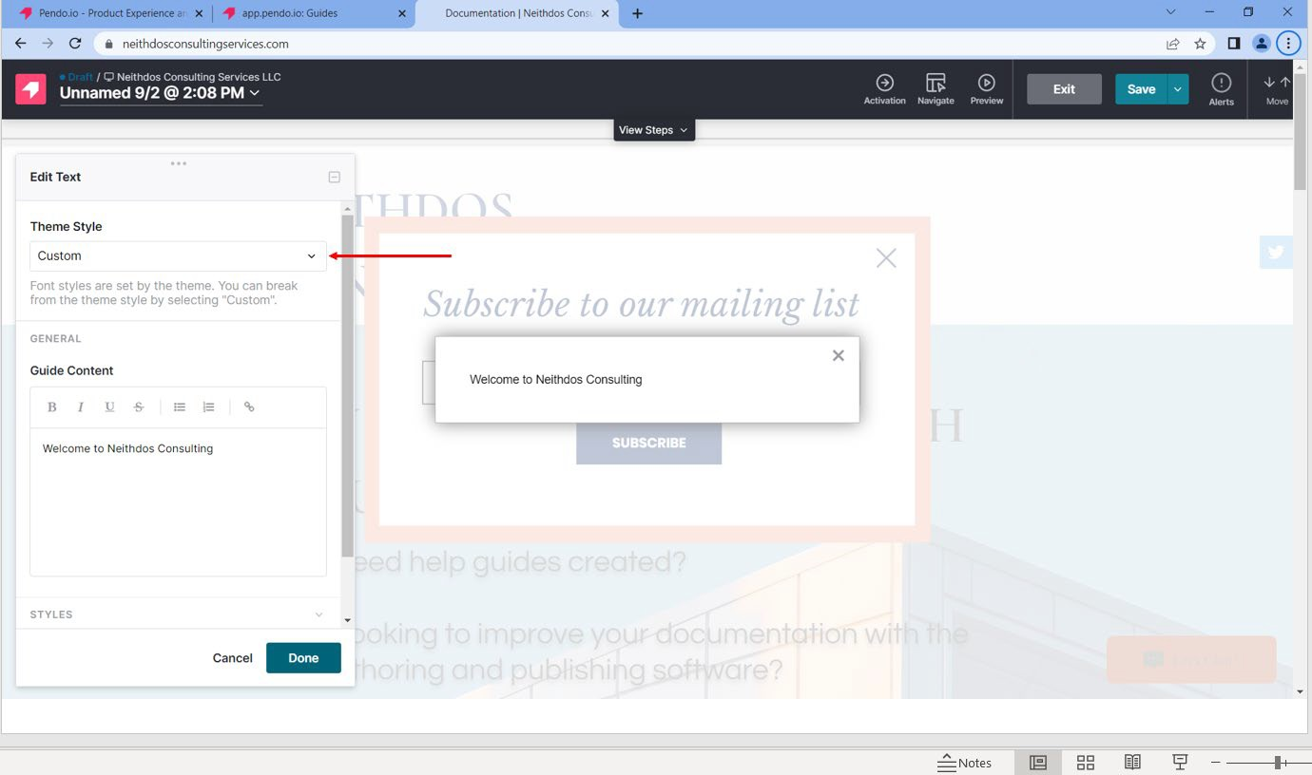

Figure 20: Custom option

1. Type the message in the Guide Content area. In this example, we will use “Welcome to Neithdos Consulting.:

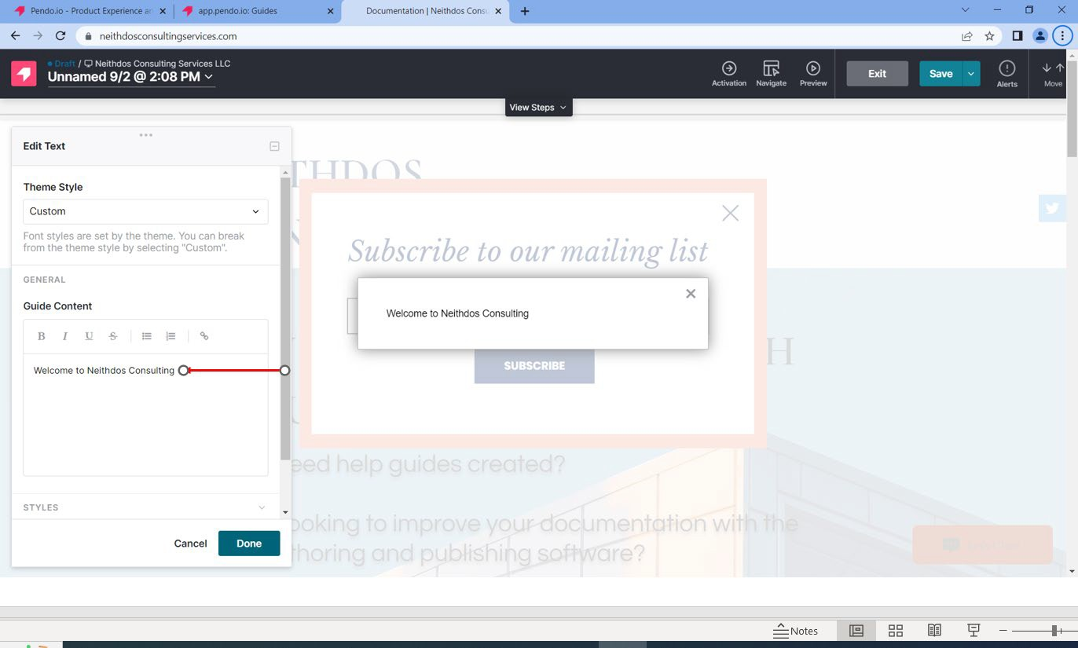

Figure 21: Customer Message

1. Click **Done**.
2. Click **Save** in the upper right corner.

Figure 22: Save button

1. Click **Exit**.

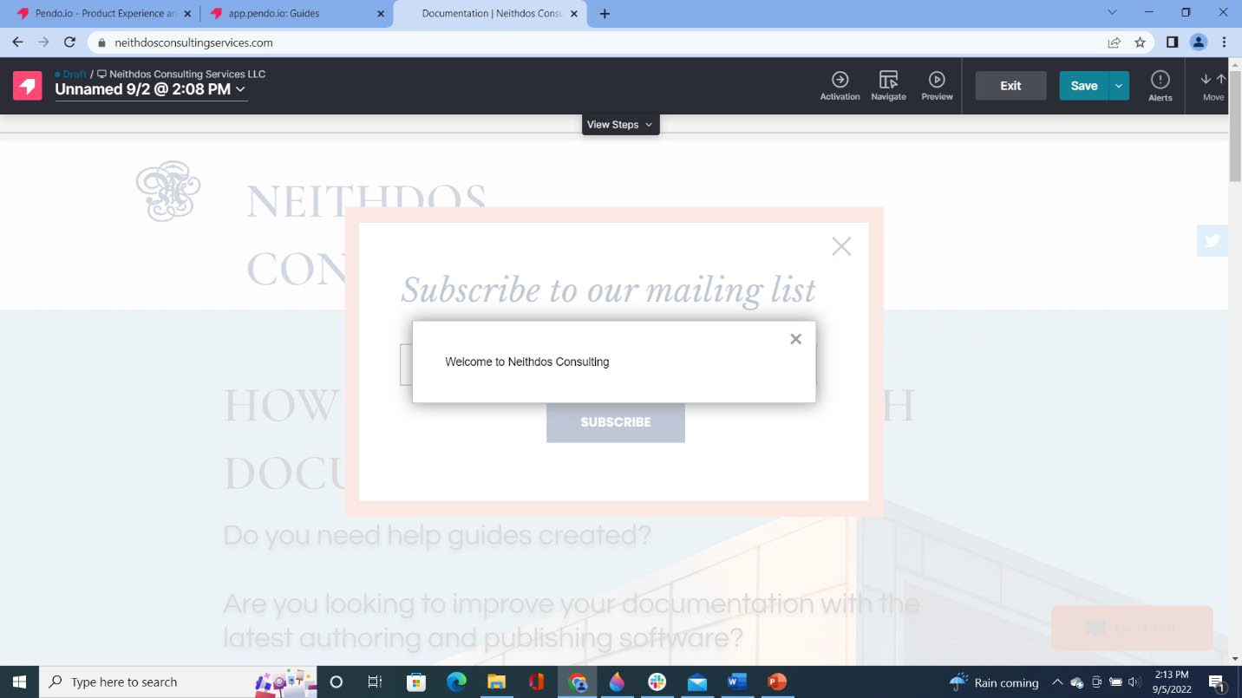

Figure 23: Exit button

1. Click **Preview**. The message appears on the website.

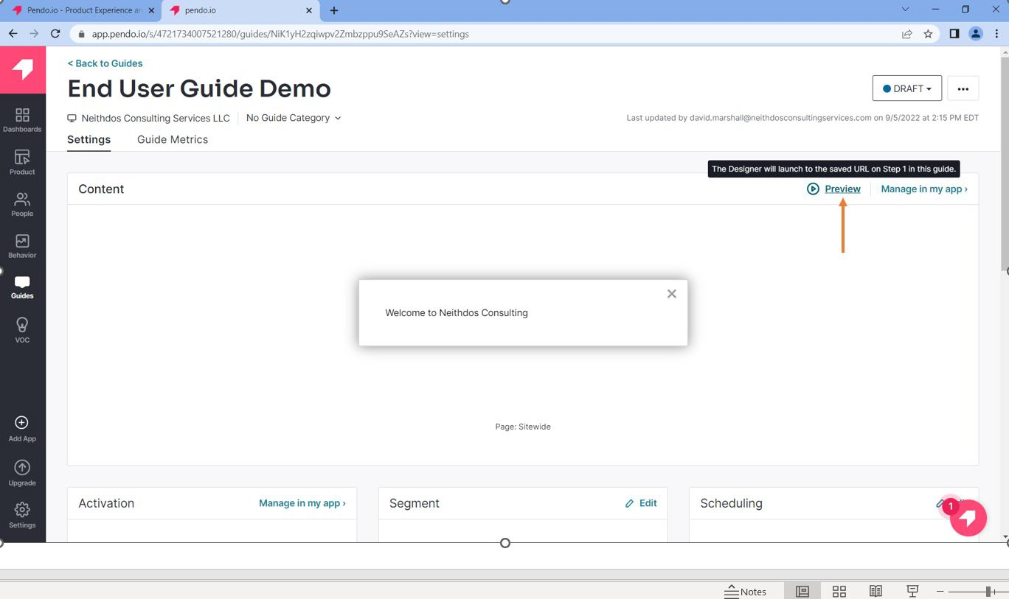

Figure 24: Preview option

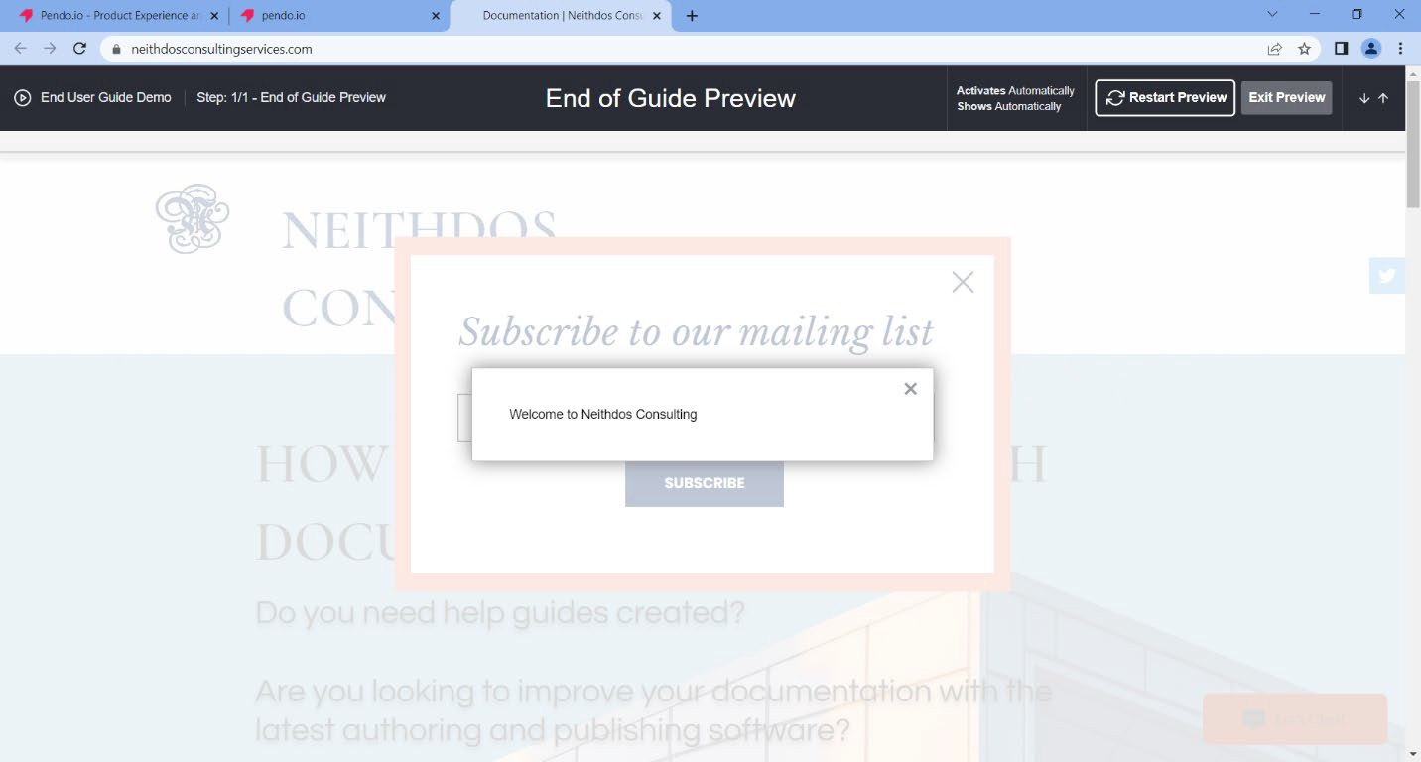

Figure 25: Website Message

1. Click **Exit Preview**.

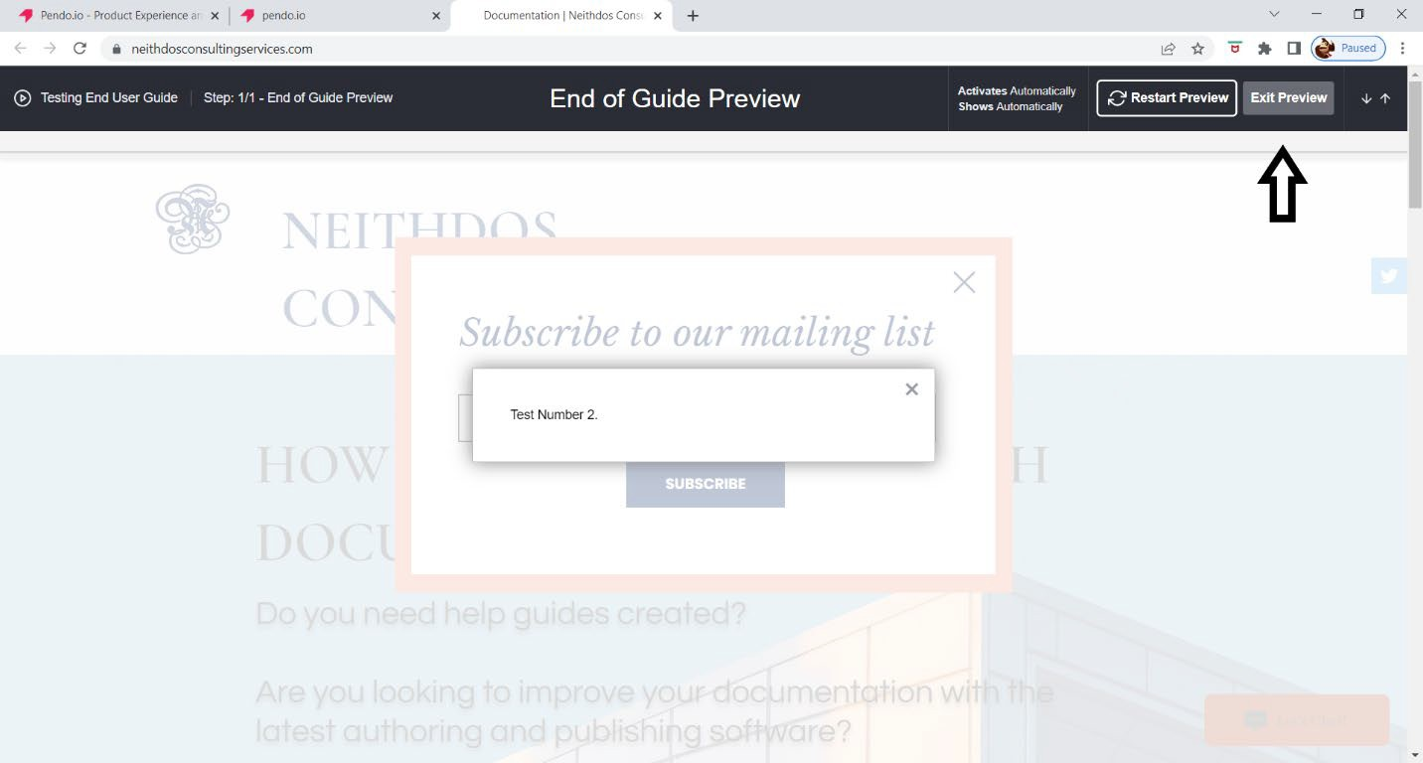

Figure 26: Exit Preview

1. Click **Back to Guides**. The newly created guide is listed in the *Guides Dashboard*.

Figure 27: Back to Guides

Figure 28: The newly created guide is listed